NAME: K Yamini
REG NO: 192572181

Write a Prolog program for Medical Diagnosis.
Aim:
To implement a simple medical diagnosis system in Prolog using symptoms, facts, and rules to identify possible conditions.
Algorithm:
- Start the program.
- Define symptoms as facts.
- Define rules connecting symptoms with possible conditions.
- Take the symptoms as input through a query.
- Prolog checks the given symptoms against the rules.
- If the symptoms match a rule, the corresponding condition is suggested.
- Display the possible condition.
- Stop the program.
Prolog program:
% EXPERIMENT 28
% Medical Diagnosis

% Symptom facts
symptom(yamini, fever).
symptom(yamini, cough).
symptom(yamini, cold).

symptom(rahul, fever).
symptom(rahul, headache).

symptom(priya, cough).
symptom(priya, sore_throat).

% Diagnosis rules
diagnosis(Person, common_cold) :-
symptom(Person, cough),
symptom(Person, cold).

diagnosis(Person, flu) :-
symptom(Person, fever),
symptom(Person, cough).

diagnosis(Person, fever_condition) :-
symptom(Person, fever),
symptom(Person, headache).

diagnosis(Person, throat_infection) :-
symptom(Person, cough),
symptom(Person, sore_throat).

% Display diagnosis
show_diagnosis(Person) :-
diagnosis(Person, Disease),
write('Person: '),
write(Person),
nl,
write('Possible Condition: '),
write(Disease),
nl.
Input:
?- show_diagnosis(yamini).
Output :
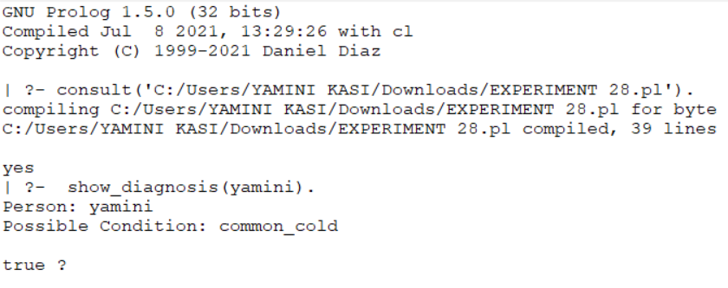
Result:
Thus, the Prolog program for a simple medical diagnosis system was successfully implemented using symptoms, facts, and rules.

